EU Agencies join 10 year anniversary of EU’s Fundamental Rights Charter

* 12TH NOVEMBER 2019

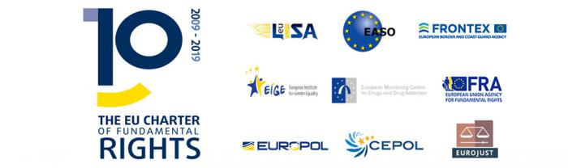

***The nine EU Justice and Home Affairs Agencies are marking the 10-year anniversary of the EU’s Charter of Fundamental Rights by pledging to continue to respect and promote fundamental rights throughout the work.***

“EASO’s mission is to support Member States in implementing a core Fundamental Right of the Union recognised by the Charter: the Right to Asylum.”, says Nina Gregori, Executive Director of the European Asylum Support Office (EASO). “This joint commitment by the Justice and Home Affairs’ Agencies is a great place to reaffirm our ongoing efforts towards implementing the Charter.”

The agencies have agreed to continue to promote and protect fundamental rights throughout their work. This includes ensuring their work always complies with the Charter.

They will continue to uphold fundamental rights in their working practices such as promoting gender equality and diversity at work.

They will also run awareness raising activities, staff training and joint training activities for Member States and third countries in order to increase awareness about the Charter and its entitlements.

In addition, they will continue to build and enhance their capacity to respect the Charter by sharing and exchanging best practices. This will form part of their regular network meetings of Justice and Home Affairs Agencies, chaired this year by the European Police Office (EUROPOL).

The nine agencies are the: European Union Agency for the Operational Management of Large-Scale IT Systems in the Area of Freedom, Security and Justice (eu-LISA); European Asylum Support Office (EASO); European Border and Coast Guard Agency (Frontex); European Institute for Gender Equality (EIGE); EU Agency for Fundamental Rights (FRA); European Police Office (EUROPOL); EU Agency for Law Enforcement Training (CEPOL); European Monitoring Centre for Drugs and Drug Addiction (EMCDDA); EU Judicial Cooperation Unit (EUROJUST).

It builds on a previous commitment by all EU agencies to strengthen [fundamental rights’ protection](https://fra.europa.eu/en/news/2015/strengthen-fundamental-rights-protection-all-eu-agencies-sign-joint-statement) in their work.

**Read the statement in full here:**

* [**Heads of JHA Agencies’ statement on the occasion of the 10th Anniversary of the Charter of Fundamental Rights of the European Union**](https://easo.europa.eu/sites/default/files/Joint-statement-10th-Anniversary-EU-Statement-Fundamental-Rights.pdf)

The statement is being released during the [2019 Conference on the EU Charter of Fundamental Rights](https://ec.europa.eu/info/events/2019-conference-eu-charter-fundamental-rights-2019-nov-12_en) to mark 10 years of the Charter. The event is organised by the European Commission and the Finnish Presidency of the Council of the EU and FRA. It takes place in Brussels on 12 November.

For more information about the JHA Agencies Network, please visit [Europol’s website](https://www.europol.europa.eu/activities-services/justice-and-home-affairs-jha-agencies-network).